CSC 122 001 Computer Science II

Julius Ranoa

Chapter 11 Programming Challenge 11 Prime Number Generation

Write a program that asks the user to enter an integer greater than 1 and prints the list of all prime numbers less than or equal to the number entered. Your program should use a predicate that determines whether a given integer is composite. The program should generate the list of prime numbers less or equal to X by adding all positive integers greater than 1 to a vector and then using *remove_if* function and the predicate to remove all composites from the vector.

Screenshot of runtime.

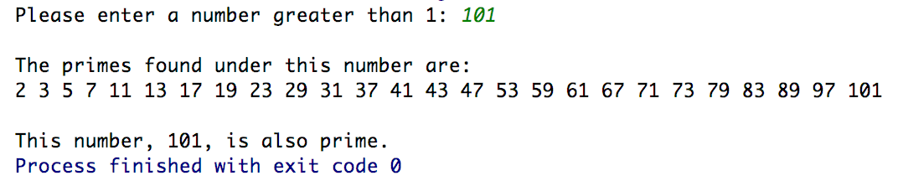

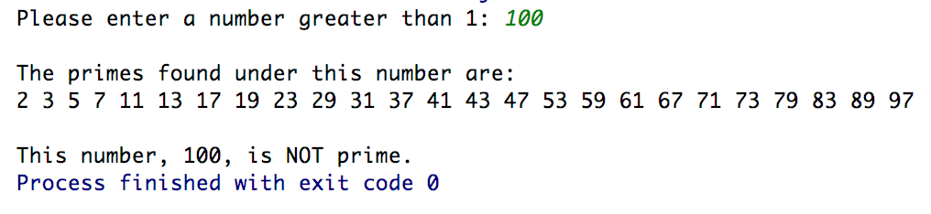

Files included: (1) IsComposite.h, (2) main.cpp

**IsComposite.h**

#ifndef **CH11_PR11_PRIME_NUMBER_GENERATION_ISPRIME_H**#define **CH11_PR11_PRIME_NUMBER_GENERATION_ISPRIME_H  
  
class** IsComposite {  
  
**public**:  
 **bool operator**()(**int** n) {  
 **for** (**int** i = 2; i < n; i++) {  
 **if** (n % i == 0) {  
 **return true**;  
 }  
 }  
 **return false**;  
 }  
  
};  
  
  
#endif *//CH11_PR11_PRIME_NUMBER_GENERATION_ISPRIME_H*

**main.cpp**

#include **<iostream>**#include **<vector>**#include **"IsComposite.h"**  
  
**int** main() {  
 **int** limit;  
 std::cout << **"Please enter a number greater than 1: "**;  
 std::cin >> limit;  
 std::cout << **"\n"**;  
  
 **if** (limit <= 1) {  
 std::cout << **"Invalid number. Re-run the program \n"**;  
 std::cout << **"and pass a proper argument"**;  
 **return** -1;  
 }  
  
 *// Fill the vector with 2 to limit* std::vector<**int**> primes;  
 **for** (**int** i = 2; i <= limit; i++) {  
 primes.push_back(i);  
 }  
  
 *// Remove all composite numbers from vector* **auto** fi = std::remove_if(primes.begin(), primes.end(), IsComposite());  
 */* Lambda version of the above statement.  
 auto fi = std::remove_if(primes.begin(), primes.end(),  
 [ ](int n){  
 for (int i = 2; i < n; i++) {  
 if (n % i == 0) {  
 return true;  
 }  
 }  
 return false;  
 }  
 );  
 */* primes.erase(fi, primes.end());  
  
 std::cout << **"The primes found under this number are: \n"**;  
 **for** (**int** i : primes) {  
 std::cout << i << **" "**;  
 }  
 std::cout << **"\n\n"**;  
  
 **if** (primes.back() == limit) {  
 std::cout << **"This number, "** << limit << **", is also prime."**;  
 } **else** {  
 std::cout << **"This number, "** << limit << **", is NOT prime."**;  
 }  
 **return** 0;  
}